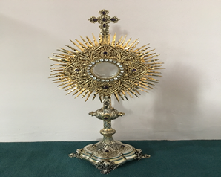**EUCHARISTIC ADORATION**

The Parish of Hannahstown

**St Peter’s Church - Every Friday from 2 pm – 8.30 pm. Every evening Adoration & Prayer in St Peter’s Church 6.30 pm – 7.30 pm**

**https://churchmedia.tv/st-josephs-church https://churchmedia.tv/st-peters-church-2**

**ANNIVERSARIES** – Brendan Brown, Hilary Green, James & Margaret Jordan, Patsy McGarry 1st Anniversary, Billy McCullough, Annemarie McGarrity, Danny & Phyllius Rooney

& Lena Taylor RIP.

**RECENTLY DECEASED** – James Keenan RIP



**WEEKLY COLLECTIONS**

***02/12/2024 Weekly Collection £897.39***

***02/02/2024 Monthly Collection £666.91***

***Thank you to everyone for their generosity to the Parish.***

***BAPTISMS***

Baptisms are upon request and you must visit the parish office to book one. Please bring with you a copy of the baby’s long birth certificate.

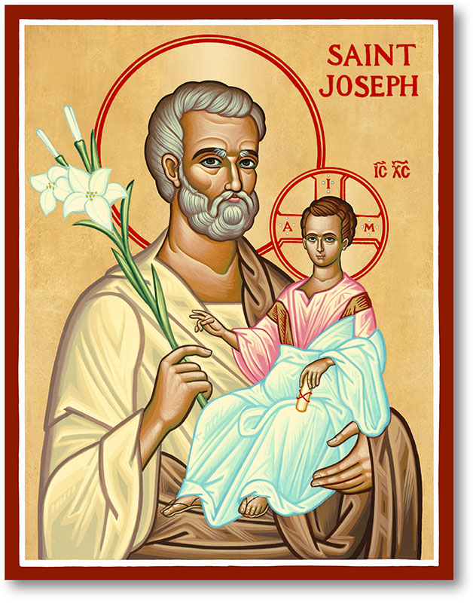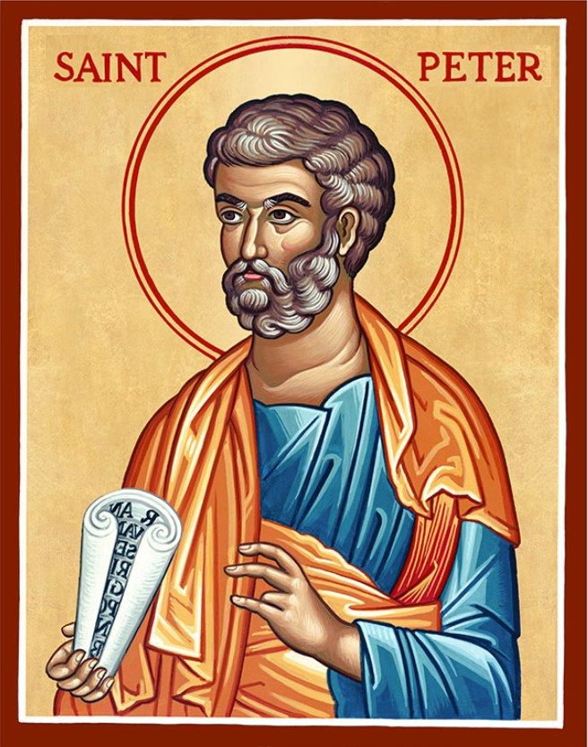

The Parish of Hannahstown

Saint Joseph’s and Saint Peter’s

**8th December 2024**

**Second Sunday of Advent**

**Vicariate / Family of Parishes Emergency Sick Calls: 07549209775**

Monday Holy Day of Obligation

Feast of the Immaculate Conception

09:15 am (Prayer for Vocations) Saint Joseph’s

Wednesday 09.15 am (Parish Novena to Our Lady) Saint Joseph’s

Thursday 09:15 am (Parish Novena to Our Lady) Saint Peter’s

Friday 09:15 am (Sacred Heart Prayer) Saint Joseph’s

Saturday 6:00 pm (St Michael the Archangel Prayer) Saint Joseph’s

Sunday 10:00 am (Prayer for Pope’s intentions) Saint Peter’s

Sunday 11:30 am (Saint Joseph Prayer) ( BSL Signed ) Saint Joseph’s

**Very Reverend Patrick Devlin Parish Priest,**

**Chaplain to the Deaf Community, Down and Connor Diocese**

**Chaplain to Antrim Area Hospital Thursday & Friday (Emergency calls)**

(Fr. Patrick’s mobile…. For Spiritual and Pastoral needs **only**, thank you) Tel: 07910 833699

Parish Secretary: Mrs Grainne McArevey [Tel: 028 90614567](Tel:02890614567)

Parish Email: [hannahstown@downandconnor.org](mailto:hannahstown@downandconnor.org) Parish Website: <https://www.parishofhannahstown.com>

**NEXT WEEK IS BAMBINELLI SUNDAY 15th DECEMBER**

**(BLESSING OF BABY JESUS CRIB FIGURES)**

Next Sunday (15th December) is Gaudete Sunday, the 3rd Sunday of Advent. Gaudete means “rejoice” and on this Sunday we rejoice because we are almost at Christmas, the day when we will celebrate the coming of Jesus into the world; the greatest gift we have ever been given. On Gaudete Sunday, our parish will join with parishes around the world, in celebrating the tradition of Bambinelli Sunday. We invite each family in the parish to bring the figurine of the Infant Jesus from their family crib to the Masses in the Parish next Sunday (12th/13th December) where they will be blessed. If you cannot be present in our Churches next Sunday but will be following Mass on the webcam, I invite you to have your figurine of the Infant Jesus present so that it can be blessed. After the blessing, you are invited to wrap the Infant Jesus figurine in Christmas wrapping paper and to place him under the tree, to be opened as the first gift of Christmas.

Please contact Anthony Adams for any enquiries on 90 309795.

HANNAHSTOWN PARISH COMMUNITY HALL

Mon – Fri 10 am – 1 pm. Monday – Coffee Morning after 9.15 am Mass. Wednesday Morning Womens Group after 9.15 am Mass

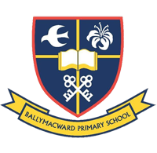**Our Parish School Ballymacward Primary School,**

THE PARISH OF HANNAHSTOWN SCHOOLS

**22 Rock Road, Stoneyford, Lisburn, Co Antrim, BT28 3SUTel: (028) 92648130, Principal: Mr Hugh Kennedy**

**Email:** [**info@ballmacwardps.lisburn.ni.sch.uk**](mailto:info@ballmacwardps.lisburn.ni.sch.uk)

**Pre-School Playgroup - Supervisor: Ms Sarah Scott. Tel: (028) 9264 8515**

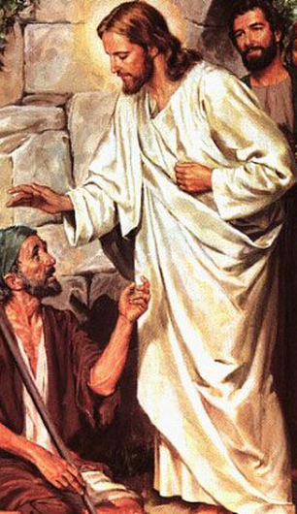**Healing Mass for the Sick** – Every first Friday in St Oliver Plunkett Church, Adoration 7:00 – 7:25, Holy Mass 7:30, Sacrament of the sick during Mass. Please bring along someone you know who would be unable to attend themselves.

HANNAHSTOWN PARISH/FAMILY OF PARISHES/PATHWAYS

**THE WEST BELFAST HISTORICAL SOCIETY -** The December meeting will take place on Friday the 13th of December at 7.30 pm in St. Michael's Parish Centre on Finaghy Road North The November talk is entitled: "WHAT THE POOR HOUSE DID FOR BELFAST" The guest speaker will be a representative from Clifton House & refreshments will be served.

HANNAHSTOWN PARISH/FAMILY OF PARISHES/PATHWAYS

**PENITENTIAL SERVICES IN THE WEST BELFAST VICARIATE**



Sunday 8th December – St Teresa’s @ 3pm (part of a Day of Prayer for Advent)

Monday 16th December – St Agnes’

Tuesday 17th December – St Oliver Plunkett’s

Wednesday 18th December – St Michael’s

**VICARIATE TRIP TO ROME 2025** - Vicariate tripOur Pastoral Community now has full details of our proposed pilgrimage  to Rome,  29 th September- 4 th October 2025, the Jubilee Year. The price is £1345 per person sharing, staying in the Hotel Campanelle Appia Park. The single supplement is £285. Note that prices are higher than usual this year because of the Jubilee. This price includes- Return flights Dublin - Rome, Breakfast and dinner each day, A full programme of spiritual activities/ visits. A checked- in baggage allowance of 10 kg plus one item of hand luggage

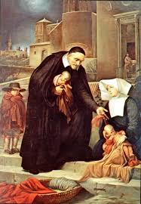**ST VINCENT DE PAUL – SVDP** Society will have their Annual Collection outside the Church after all the weekend Masses next week. Hannahstown parish would like to thank all our parishioners for their donations throughout the year.

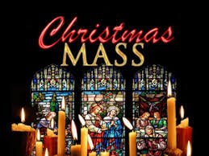**CHRISTMAS MASS TIMES**

**Christmas Eve Masses**

St Joseph’s Church @ 6 pm

St Peter’s Church @ 8 pm

**Christmas Day Masses**

St Peter’s Church @ 10 am,

St Joseph’s Church @ 11.30 am